ONLINE SHOPPING CART APPLICATION

A Paper

Submitted to the Graduate Faculty

of the

North Dakota State University

of Agriculture and Applied Science

By

Swati Gupta

In Partial Fulfillment of the Requirements

for the Degree of

MASTER OF SCIENCE

Major Program:

Software Engineering

June 2013

Fargo, North Dakota

**ONLINE SHOPPING SYSTEM**

AADIKAVI BHANUBHAKTA CAMPUS

Vyas-01, Bigyanchour, Tanahun

*Pratical on*

*System Analysis and Design*

Submitted by: Submitted To:

[Student’s Name] Achal Shah, Kushal Achhami, Sarina Dawadi Er. Ghan Bahadur Thapa

Subject Teacher

# Abstract

Online shopping is a lifestyle, e-commerce web applications, which provides various electronic and life style products. This project allows viewing various products available enables registered users to purchase desired products available enables registered users to purchase desired products instantly using now Cash on Delivery payment system can place an order by using option. This project provides easy access to Administrators and Managers to view orders placed using pay later options.

# Acknowledgement

This project work in itself is an acknowledgement to the sincerity, passion and technical assistance contributed to it by all our group members and our talented teachers. With immense gratitude we acknowledge our indebtedness to all the persons whose support and guidance have helped us in carrying out this project work dynamically and upto the standards of our prestigious institution.

We wish to express our deep respect and thankfulness to Ghan Bahadur sir, our project guide, without his guidance, insightful comments, smart encouragement and valuable help this work would not have been a success.

We have great pleasure in acknowledging the help we received from all those who favored in giving shape to this project, a sincere thanks to:

All the samples who filled out our questionnaires.

The Smart people out there who invented the Internet and Google.

And Obviously our great teachers.

Contents

Abstract 2

Acknowledgement 2

Abbreviation of Solid state drive (SSD) 4

CHAPTER 1. INTRODUCTION 4

1.1 Problem statement & Benefit of online shopping system 5

1.2 Motivation 5

1.3 Project scope and limitations 5

CHAPTER 2. OBJECTIVES 6

Two types of Requirement:- 6

2.1 Functional requirements 6

2.2 Non-functional requirements 6

CHAPTER 3. FEASIBILITY REPORT 6

3.1 Economic Feasibility 7

3.2 Operational Feasibility 7

CHAPTER 4. DIAGRAM 8

4.1 Class Diagram 8

4.2 Entity-Relationship Diagram 9

4.3 Activity Diagram 10

CHAPTER 5. DATA FLOW DIAGRAM(DFD) 11

5.1 Level -0 DFD 11

5.2 Level-1 DFD 11

5.3 Level -2 DFD 12

5.5 Use Case Diagram 13

5.5.1 Order Template 14

5.5.2 Return Template 15

5.5.3 Reports Template 16

5.6 Sequence Diagram 17

CHAPTER 6. SYSTEM IMPLEMENTATION 18

6.1 System Implementation 18

6.2 Tools Used 18

6.2.1 Front End Tools 18

6.2.2 Backend Tools 18

6.3 Detailed Scope 18

CHAPTER 7. TESTING 19

7.1 Unit Testing 19

7.2 Integration Testing 20

7.3 System Testing 21

Reference 21

List of Figure

4.1 Class Diagram 8

4.2 Entity-Relationship Diagram 9

4.3 Activity Diagram 10

5.1 Level -0 DFD 11

5.2 Level-1 DFD 11

5.3 Level -2 DFD 12

5.5 Use Case Diagram 13

5.5.1 Order Template 14

5.5.2 Return Template 15

5.5.3 Reports Template 16

5.6 Sequence Diagram 14

## Abbreviation of Solid state drive (SSD)

A Solid state drive (SSD) is a data storage device, typically used in a computer. It uses flash memory to store data even after power is turned off. SSDs are designed to access data in the same way as traditional hard disk drives.

SSD technology primarily uses electronic interfaces compatible with traditional block input/output (i/o) hard disk drives (HDDS), which permit simple replacements in common applications.

## CHAPTER 1. INTRODUCTION

This system provides an easy solution for customers to buy the product without going to the shop and also to shop owner to sale the product. This proposed system can be used by any users and it does not require any educational level, experience or technical expertise in computer field but it will be of good use if user has the good of how to operate a computer.

The online shopping System (OSS) for clothes item web shop provide complete solutions for customers through a single get way using the internet. It will enable the customers to browser through the shop and purchase them online without having visit the shop physically.

## 1.1 Problem statement & Benefit of online shopping system

The main reason for developing this project is the problems which were faced by the customers because of shortest time & convenience.

Convenience: Unlike your street market, online shopping sites never close; they are available 24 hours a day, seven day a week, and they’re only a mouse click away.

Accessibility; If you are out of state or even out of country when a money problem arises, you can log on instantly to online bank and take care of business, 24/7.

## 1.2 Motivation

The motivation for designing this shopping-cart application came because I love online shopping rather than spending lot of time at physical markets. Further, using the available stores to sell the products, there is also the possibility of designing one’s own customized shopping-cart application from scratch because custom-designed platforms are expensive. Moreover, I value recent learning about the Java and JavaScript programming languages as well as seeing how powerful and dynamic they are when it comes to web designing and applications. Apart from helping computer science students understand the concepts of web-application designing, it would be very easy to incorporate the idea of using programming techniques from the available visuals to understand how a piece of code appears on a user interface. The languages used to build this application are JavaScript, HTML, and Java because I found them to be extremely useful while working on the technologies at my workplace.

## 1.3 Project scope and limitations

Sellers can deal in a wide range of products. They can analyse customer buying patterns and preferences and offer tailor made offers, discounts, and services. Business can be easily scaled. By selling via online retail sites like Amazon, Flipkart, etc., small traders and manufacturers get the seal of legitimacy

### CHAPTER 2. OBJECTIVES

### Two types of Requirement:-

### 2.1 Functional requirements

Functional requirements (FRs) are the *what* of your website. It is all about the functions and core operations of your e-store that enable a user to take action on the website. They can be implemented as a single website feature and form the basis of the whole software development process.

Example: Add the following product filtering features to our home improvement webstore: price, popularity, power rate (Watt), heating area (m2), and usage (bathroom, kitchen, etc).

### 2.2 Non-functional requirements

Non-functional requirements (NFRs) are the *how* of your website. Named quality attributes of a system, they form user experience and imply some global, abstract expectations from the product. Non-functional requirements may derive from a sum of functional requirements and are implemented as a sum of web features

Example*:* Products should be easily found and have an appealing display on the website.

### CHAPTER 3. FEASIBILITY REPORT

Feasibility is an important phase in the software development process it enables the development process it enables the developers to have an assessment of the product being developed it refers to the feasibility study of the product in terms of outcomes of the product, operational required for implement ting it. Feasibility study should be performed on the basic of various criteria and parameters. The various feasibility studies are:-

3.1 Economic Feasibility

3.2 Operational Feasibility

### 3.1 Economic Feasibility

It refers to the benefits or outcomes we are deriving from the product as compared to the total cost we are spending for developing the benefits are more or less the same as the older then it is not feasible to develop the product.The product is economical feasible. The E-governance provides the following benefits to primary school of Orissa.

* Reduces the processing time.
* Reduces the work load.
* Administrative will be effective.

### 3.2 Operational Feasibility

It refers to the feasibility of the product to be operational. Some products may work very well at the design and implementation but many fail in the real time environment. It introduces the study of human resources required and their technical expertise.

This product is operationally feasible as it is designed specifically for E-governance. This provides consistent and integrated data management. It also provides information at all levels of people.

### CHAPTER 4. DIAGRAM

### 4.1 Class Diagram

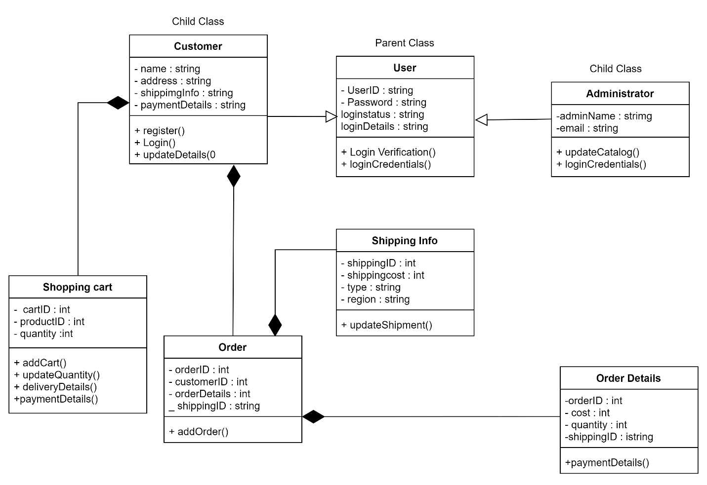

**Figure: Class diagram**

### 4.2 Entity-Relationship Diagram

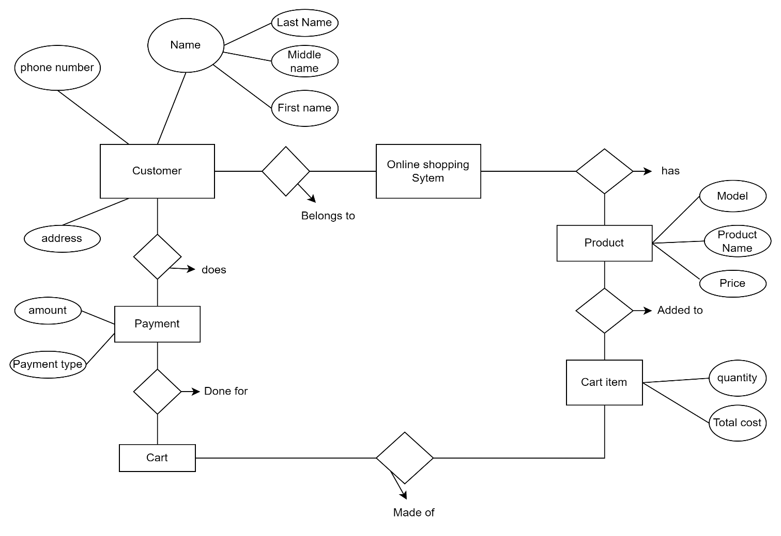

**Figure: E-R Diagram**

### 4.3 Activity Diagram

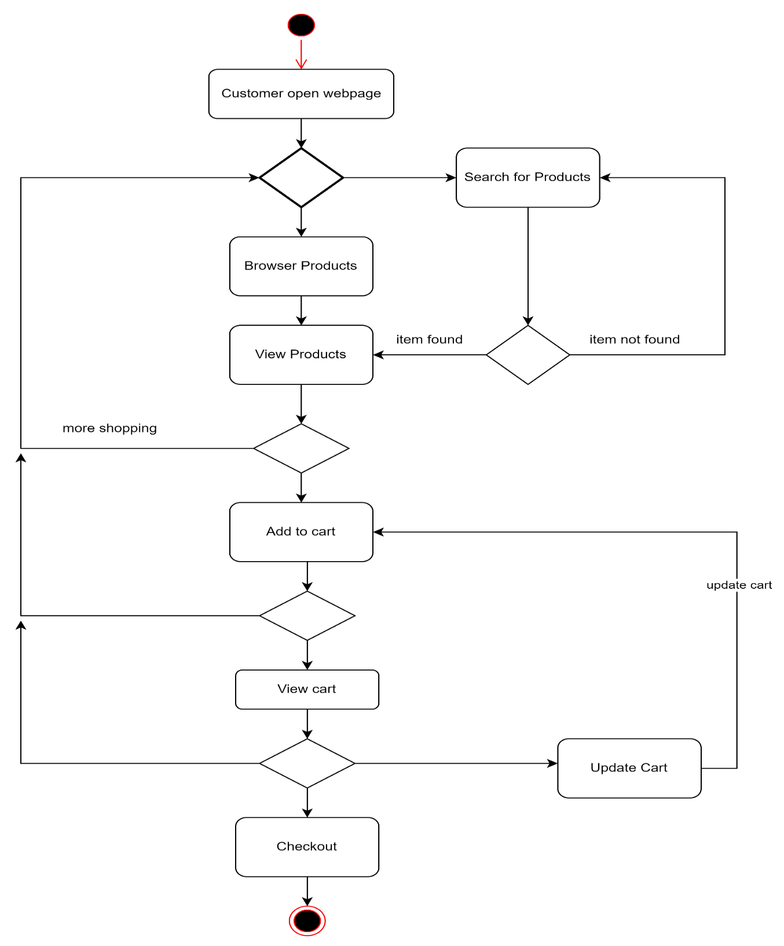

**Figure: Activity Diagram**

### CHAPTER 5. DATA FLOW DIAGRAM(DFD)

### 5.1 Level -0 DFD

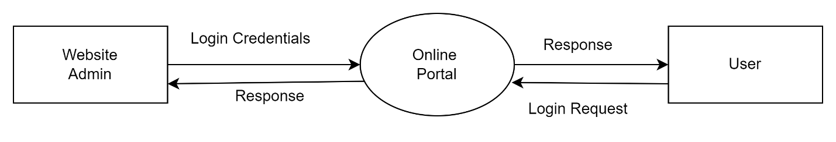**Figure: Level-0 DFD**

### 

### 5.2 Level-1 DFD

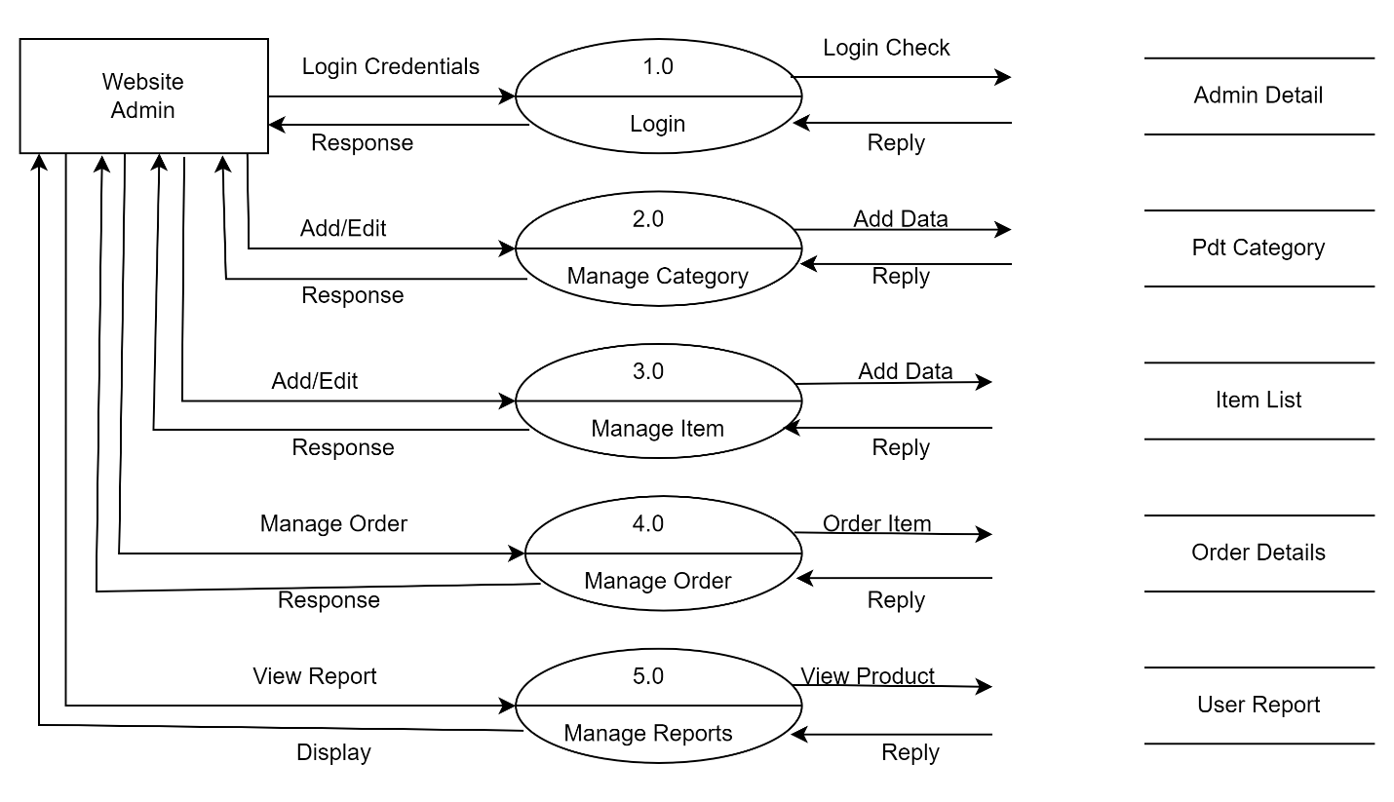

**Figure: Level-1 DFD**

### 5.3 Level -2 DFD

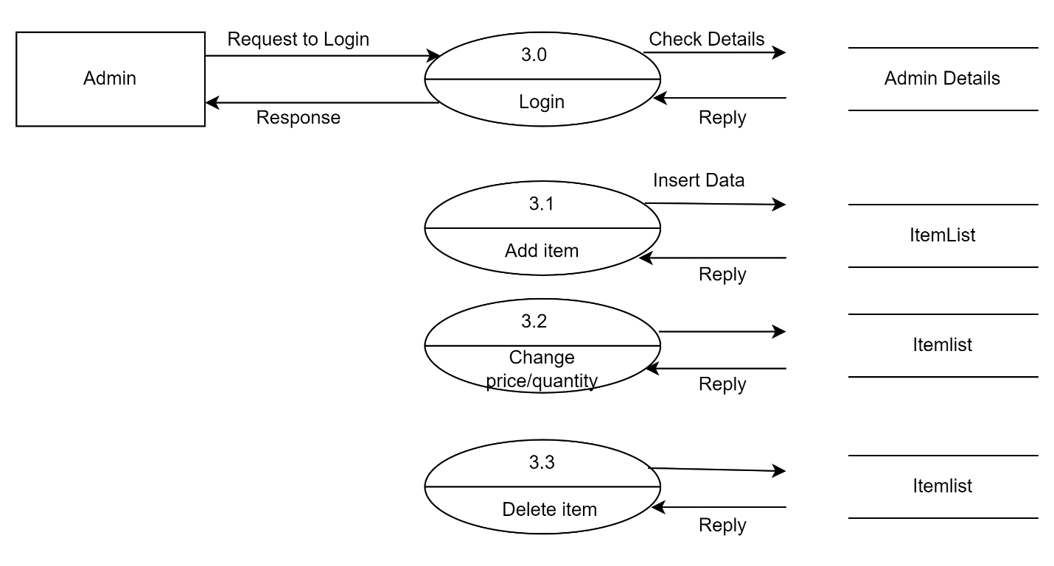**Figure: Level-2 DFD**

### 5.5 Use Case Diagram

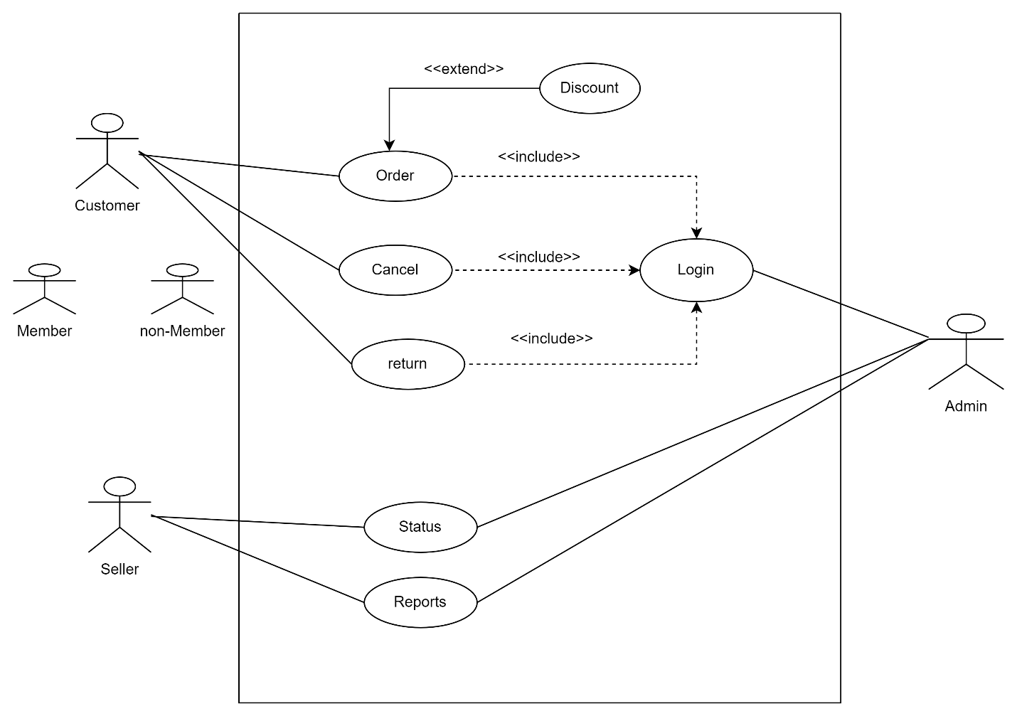

**Figure: Use Case Diagram**

### 5.5.1 Order Template

|  |  |
| --- | --- |
| Use case ID: | 1.0 |
| Use case name: | Order |
| Created by: | Sarina, Kushal, Achal Last updated by: |
| Date created by: | July 9,2022 Date last updated: |

|  |  |
| --- | --- |
| Actors: | Seller, Admin |
| Description: | Seller provides the list of the varieties of the available items and admin look over all the orders |
| Precondition: | Seller put all the products into review |
| Postcondition: | * Seller provides the list of the available items * Admin keeps the records of the ordered items |
| Normal Course: | * Seller shows their available items * Seller mentions their price of the products and after order is done * Seller sells their products * Admin keeps the records of the transactions |
| Alternative course: |  |
| Exceptions: | * Sellers not providing all the exacts details of the items |
| Includes: |  |
| Priority: | Medium |
| Frequency of use: | Everyday |
| Business rule: | No return only exchange |
| Assumptions: | Nill |
| Notes and issues: | Damaged products will be exchanged |
| Use case graphic: |  |

### 5.5.2 Return Template

|  |  |
| --- | --- |
| User Case ID | 2.0 |
| User Case Name | Return |
| Created by | Achal, Kushal, Sarina Last updated by: |
| Date created | Jul 11,2022 Date last updated: |

|  |  |
| --- | --- |
| Actors: | System user, Dealers, Customer Service |
| Descriptions: | Call Customer service. If you are unsure of any aspect of returning an item, call or email customer service for the website that you purchased the item from. |
| Pre-conditions: | Verify Product returns request. |
| Post-conditions: | Create a return request. |
| Normal Course: | * Process payment & complete return. * Refund by original payment method. * Refund by cash. * Refund by points or vouchers. |
| Alternate course: | Complete in-store product returns.  Return item to inventory. |
| Exceptions: | We offer free returns within 30 days of purchase. |
| Includes: | * Stipulate a time frame for returns. * Define a time frame for returns. * List return requirements. * Choose refund or in-store edit. |
| Priority: | High |
| Frequency of use: | Often (20%) |
| Business rules: | Return policies are the rules a retailer creates to manage how customers return and exchange unwanted merchandise they purchased. |
| Special requirement: | Enhanced shopping cart flexible return policy mobile-friendly website. |
| Assumptions: | Nill |
| Note & Issues: | Returns from online sales, particularly returns to store, are seriously impacting company profits. |
| Use Case Graphic: |  |

### 5.5.3 Reports Template

|  |  |  |  |
| --- | --- | --- | --- |
| Use case ID: | 3.0 | | |
| Use case name: | Reports | | |
| Created by: | Kushal, Sarina, Achal | Last updated by: |  |
| Date created: | July 9, 2022 | Date last updated: |  |

|  |  |
| --- | --- |
| Actor(s): | Seller, Admin |
| Description: | Seller provide the detail of their products and admin take reports of the products. |
| Preconditions: | Seller put their products into sale. |
| Postconditions: | * Seller sells their products. * Admin keeps the record of transaction. |
| Normal course: | * Seller put their products into sale. * Seller provide the detail of their product. * Seller sells their products. * Admin keeps the record of transaction. |
| Alternative course: |  |
| Exceptions: | * Seller not providing the exact detail of their products. |
| Includes: |  |
| Priority: | Medium |
| Frequency of use: | Everyday |
| Business Rules: | Report collection and management of correct and detailed information of all products. |
| Special Requirement: |  |
| Assumptions: | Nill |
| Notes and issues: | Damaged products |
| Use case Graphic: |  |

### 5.6 Sequence Diagram

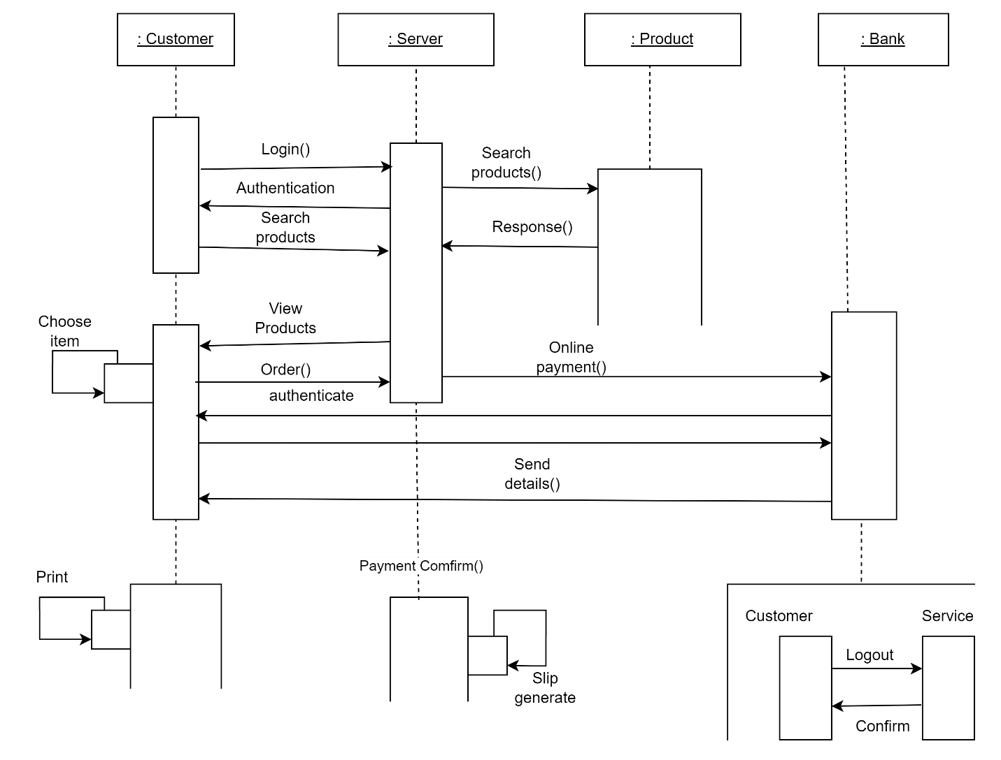

**Figure: Sequence Diagram**

### CHAPTER 6. SYSTEM IMPLEMENTATION

CHAPTER 3. IMPLEMENTATION

This chapter includes the detailed design used to build the online shopping-cart

application. The system's design is used to create the functions and operations of the gathered

requirements in detail, including screen layouts, business rules, process diagrams, and other

documentation. The output of this chapter describes the new system which is defined as a

collection of modules and subsystems. This design stage takes the initial input requirements that

were identified in the approved requirements specification document. For each requirement,

there is a set of one or more design elements that are produced using the different prototypes.

These design elements describe the desired software features, in detail, including functional

hierarchy diagrams, screen layouts, activity diagrams, and class diagrams. The intention of these

diagrams is to describe the software in detail so that the system can develop the application with

less additional design input. The system’s mock screen shots are shown later in this chapte

### 6.1 System Implementation

This includes the detailed design used to build the online shopping application. The system's design is used to create the functions and operations of the gathered requirements in detail, including screen layouts, business rules, process diagrams, and other documentation. The output of this chapter describes the new system which is defined as a collection of modules and subsystems. This design stage takes the initial input requirements that were identified in the approved requirements specification document. For each requirement, there is a set of one or more design elements that are produced using the different prototypes.These design elements describe the desired software features, in detail, including functional hierarchy diagrams, screen layouts, activity diagrams, and class diagrams. The intention of these diagrams is to describe the software in detail so that the system can develop the application with less additional design input. The system’s mock screen shots are shown later.

### 6.2 Tools Used

### 6.2.1 Front End Tools

* HTML, CSS, JavaScript.
* HTML: Html is used to create and save web document.
* CSS: CSS for creative attractive layout and design.
* JS: Dynamic user interaction

### 6.2.2 Backend Tools

* PHP
* PHP: Dynamic with user, admin and database.
* MySQL: Database server for storing information
* XAMPP

### 6.3 Detailed Scope

This project is supposed to be delivered in three phases, with each phase being an add-on

to the project that makes it more usable and acceptable.

1. In the first delivery, the application must be able to add an item to the shopping cart and case.

• Browse categories on the home page

• Select a category and browse through the items

• View more information about an item.

• Add an item to the shopping cart.

• Continue shopping or go to checkout for the item.

1. The application must be able to check out the items in the cart.

• Check out the items.

• Continue shopping.

• Delete the items to update the shopping cart.

1. The application asks for user authentication before checking out.

• Add items to the cart.

• Check out the items.

• Log in with a valid username and password.

1. The application must bring up the order form for the check out.

• Complete the information on the order form.

• Place the order.

### CHAPTER 7. TESTING

Software testing is a process of running with intent of finding errors in software. Software testing assures the quality of software and represents final review of other phases of software like specification, design, code generation etc.

### 7.1 Unit Testing

Unit testing emphasizes the verification effort on the smallest unit of software design i.e. a software component or module. Unit testing is a dynamic method for verification, where program is actually compiled and executed. Unit testing is performed in parallel with the coding phase. Unit testing tests units or modules not the whole software.

I have tested each view/module of the application individually. As the modules were built up testing was carried out simultaneously, tracking out each and every kind of input and checking the corresponding output until module is working correctly.

In the Shop Products Module when a product has been added to cart it has been made sure that if the item already exists in the shopping cart then the quantity is increased by one else a new item is created in the shopping cart. Also the state of the system after a product has been dragged in to the shopping cart is same as the state of the system if it was added by clicking the add to cart button. Also it has been ensured that all the images of the products displayed in the shop products page are drag gable and have the product property so that they can be dropped in the cart area.

In the Product Description Module it has been tested that all the images are displayed properly. Users can add review and the as soon as a user adds a review it is updated in the view customer review tab. It has been checked to see if the whole page refreshes or a partial page update happens when a user writes a review.

Methods were written to retrieve all the manufacturers from the database, strings that match a certain search term, products that match certain filter criteria, all images that belong to a particular product etc. Unit test cases were automatically generated for these methods.

### 7.2 Integration Testing

In integration testing a system consisting of different modules is tested for problems arising from component interaction. Integration testing should be developed from the system specification. Firstly, a minimum configuration must be integrated and tested.

In my project I have done integration testing in a bottom up fashion i.e. in this project I have started construction and testing with atomic modules. After unit testing the modules are integrated one by one and then tested the system for problems arising from component interaction.

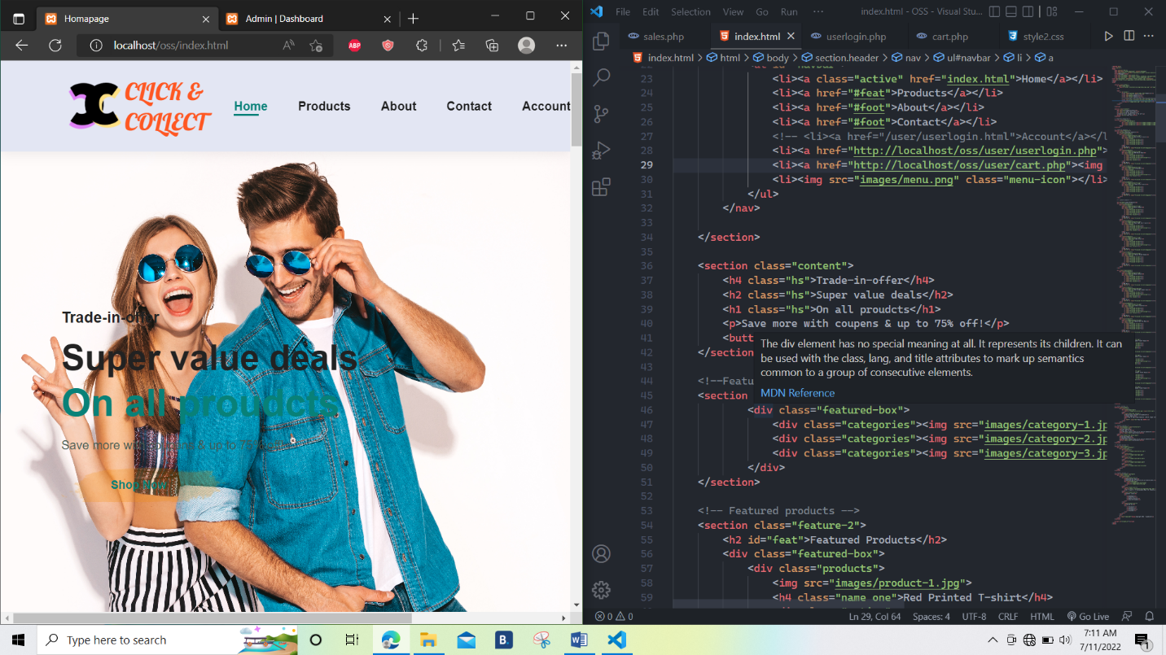

**Figure: Unit Testing**

### 7.3 System Testing

The process of testing of an integrated hardware and software system to verify that the system meets it’s specified requirements. Verification: Confirmation by examination and provisions of objective evidence that specified requirements have been fulfilled. To test the system as a whole, requirements and expectations should be clear and the tester needs to understand real time usage of application too.

1. Installation of Computing Platform

Install proposed system to run project. In this system windows platform is required. So first of all install windows 98/20000/XP/8/10 operating system.

1. Technology Testing

Install sufficient hardware such as monitor, printer, keyboard etc. on site. Help also can provide to user to meet timing demands & balance job mix.

1. Program Testing

After the modules were tested & integrated with software packages both valid & invalid test transaction were run to test software system

1. Input Testing

User will be tested to determine if they are completing the forms correctly, accuracy & speed of data entry personnel will be Evaluate the efficiency of screen input layout will be evaluated.

1. Output Testing

View & enquiry screen will be tested for accuracy based on live data is entered during the training sessions. All reports will be issued to the final users, & each user will be required to fill out a questionnaire if the view reports Meets his/her information needs.

### Reference

[1]. Ajzen, I. The theory of planned behavior. Organizational behavior and human decision processes, 50(2), pp.179-211,1991.

[2]. Arnold, M.J., and Reynolds, K.E. Hedonic shopping motivations. Journal of retailing, 79(2), pp.77-95, 2003. [3]. Da Cruz, W.B., and Melleiro, M.M. Assessment levels of the user’s satisfaction in a private hospital. Rev Esc Enferm USP, 44(1), pp.147-53, 2010.

[3]. P.S. Venkateswaran, Dr. A. Sabarirajan, S. S. Rajest, And R. Regin. The Theory of the Postmodernism in Consumerism, Mass Culture, and Globalization. The Journal of Research on the Lepidoptera Volume 50 (4): 97-113, 2019.